**Table of Contents**

|  |  |  |
| --- | --- | --- |
| SNO. | INDEX | PAGE NO. |
| 1. | Introduction. |  |
| 2. | Objectives. |  |
| 3. | System Flowchart Diagram. |  |
| 4. | Data Flow Diagram (DFD). |  |
| 5. | Entity-Relationship Model Diagram (ER). |  |
| 6. | Screen Shots. |  |

INTRODUCTION

## Introduction

This project is designed so as to be used by Car Rental Company specializing in renting cars to customers. It is an online system through which customers can view available cars, register, view profile and book car.

## Reason for the Project

The advancement in Information Technology and internet penetration has greatly enhanced various business processes and communication between companies (services provider) and their customers of which car rental industry is not left out. This E-Car Rental System is developed to provide the following services:

* Enhance Business Processes: To be able to use internet technology to project the rental company to the global world instead of limiting their services to their local domain alone, thus increase their return on investment (ROI).
* Online Vehicle Reservation: A tools through which customers can reserve available cars online prior to their expected pick-up date or time.
* Customer’s registration: A registration portal to hold customer’s details, monitor their transaction and used same to offer better and improve services to them.
* Group bookings: Allows the customer to book space for a group in the case of weddings or corporate meetings (Event management).

## Problem Statement

A car rental is a vehicle that can be used temporarily for a fee during a specified period. Getting a rental car helps people get around despite the fact they do not have access to their own personal vehicle or don't own a vehicle at all. The individual who needs a car must contact a rental car company and contract out for a vehicle. This system increases customer retention and simplify vehicle and staff management.

## Aims & Objectives

To produce a web-based system that allow customer to register and reserve car online and for the company to effectively manage their car rental business. To ease customer’s task whenever they need to rent a car.

## Scope

This project traverses a lot of areas ranging from business concept to computing field, and required to perform several researches to be able to achieve the project objectives.

The area covers include:

* Car rental industry: This includes study on how the car rental business is being done, process involved and opportunity that exist for improvement.
* PHP Technology used for the development of the application.
* General customers as well as the company’s staff will be able to use the system effectively.
* Web-platform means that the system will be available for access 24/7 except when there is a temporary server issue which is expected to be minimal

**Specification of Language:-**

* **Forntend Technology:-**
* **HTML (Hypertext Markup Language).**
* **CSS (Cascading Style Sheet).**
* **BOOTSTRAP.**
* **Backend Technology:-**
* **PHP(Hypertext Preprocessor).**
* **Javascript.**
* **DataBase Handling Technology:-**
* **PhpMyAdmin.**

SYSTEM FLOW DIAGRAM

Log Out

Car Booking

Update all Information

Car Search

Add Car Details

Is Admin?

Is Valid?

LOGIN

REGISTRATION

IF REGISTER?

# DATA FLOW DIAGRAMS

## Data Flow Diagram (DFD)

A Data Flow Diagram (DFD) is a graphical representation that depicts the information flow and the transforms that are applied as data moves from input to output.

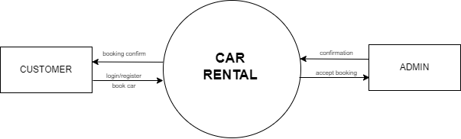**Zero Level :-**

**Zero Level DFD.**

**First Level :-**

ONLINE CAR

RENTAL

. SYSTEM

CUSTOMER

ADMIN

RESERVE A CAR

CAR RESERVED

NEW

REGISTRATION

LOGIN REQUEST

AUTHENTICATION

REGISTRATION CONFIRMATION

ADD

C

USTOMER

TRANSACTION

REPORTS

**First Level DFD.**

Functions of Customer:

* New Registration
* Login Request
* Registration Confirmation by the System
* Book a Car

Functions of Car Rental Company:

* Manage vehicles
* Manage Brands
* View customers
* Manage Bookings

**ER DIAGRAM(ENTITY RELATIONSHIP DIAGRAM):-**

The Entity-Relationship (ER) model was originally proposed by Peter in 1976 as a way to unify the network and relational database views. Simply stated the ER model is a conceptual data model that views the real world as entities and relationships. A basic component of the model is the Entity-Relationship diagram which is used to visually represent data objects.

Since Chen wrote his paper the model has been extended and today it is commonly used for database design for the database designer, the utility of the ER model.

It is simple and easy to understand with a minimum of training.

Therefore, the model can be used by the database designer to communication the design to the end user.

**ER DIAGRAM:-**

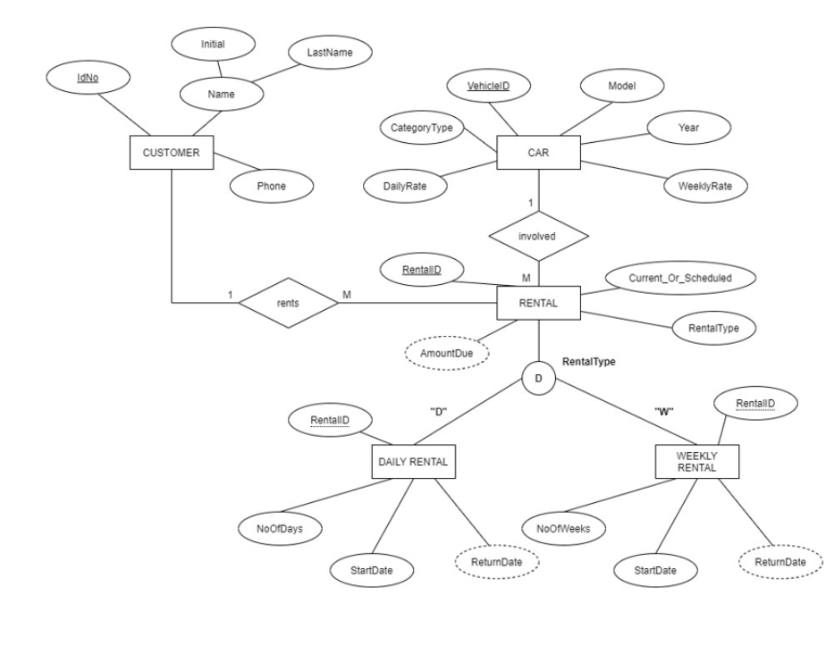

**Screen Shots:-**

* **Home Page:-**

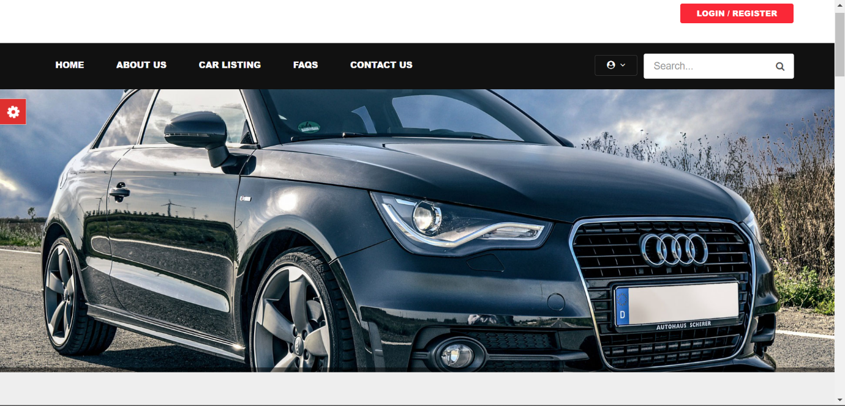

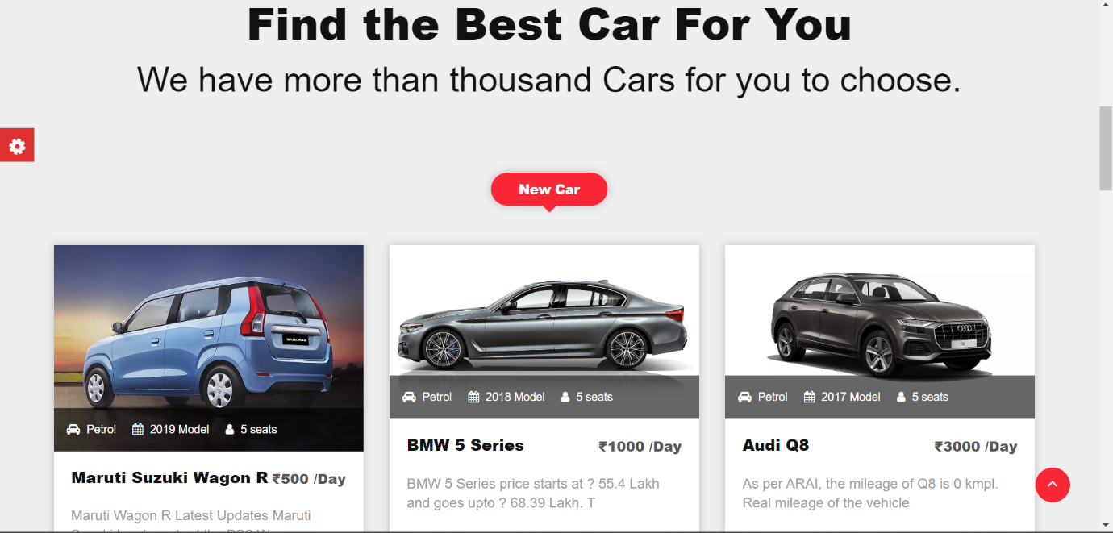

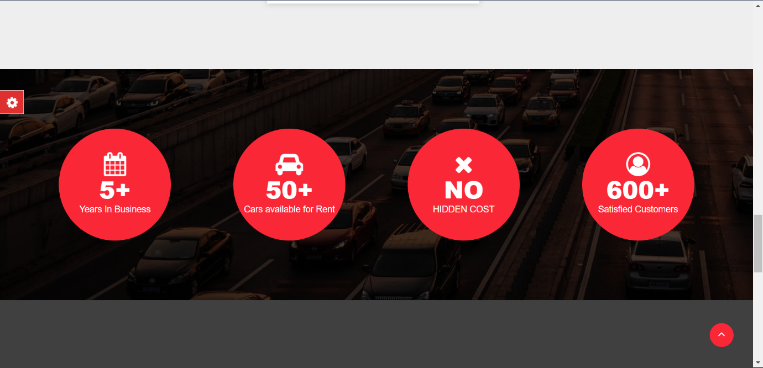

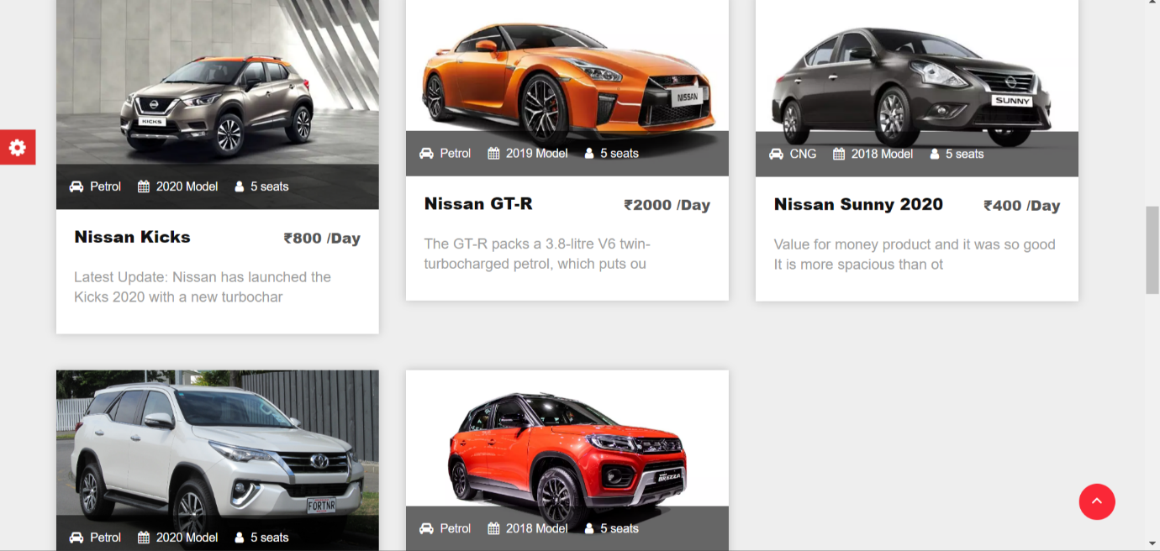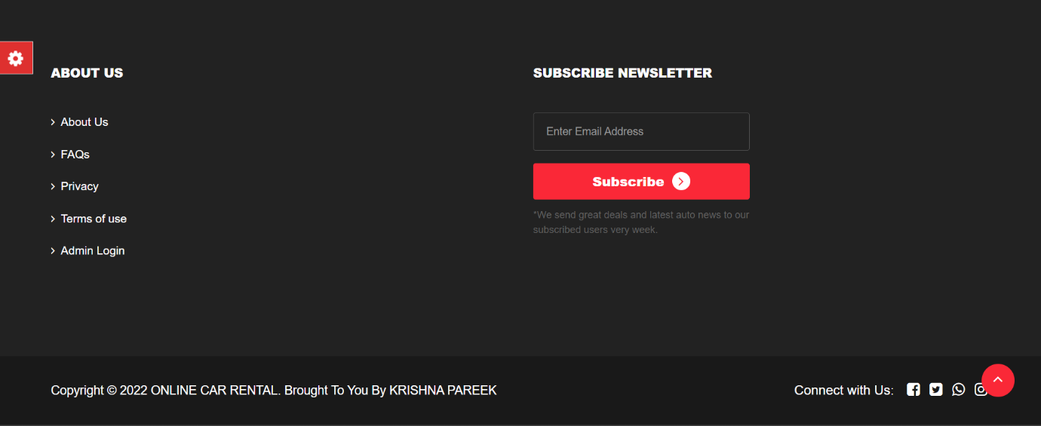

* **About Us Page:-**

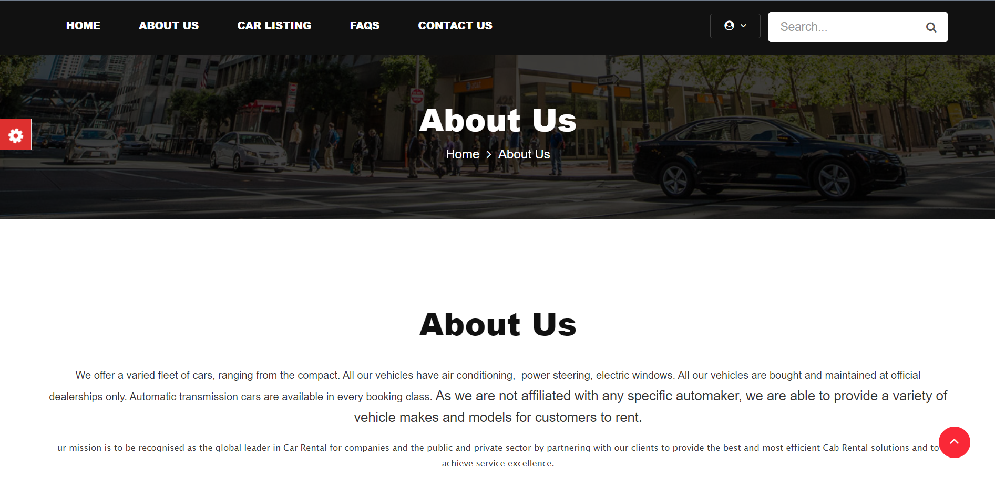

* **Car List Page:-**

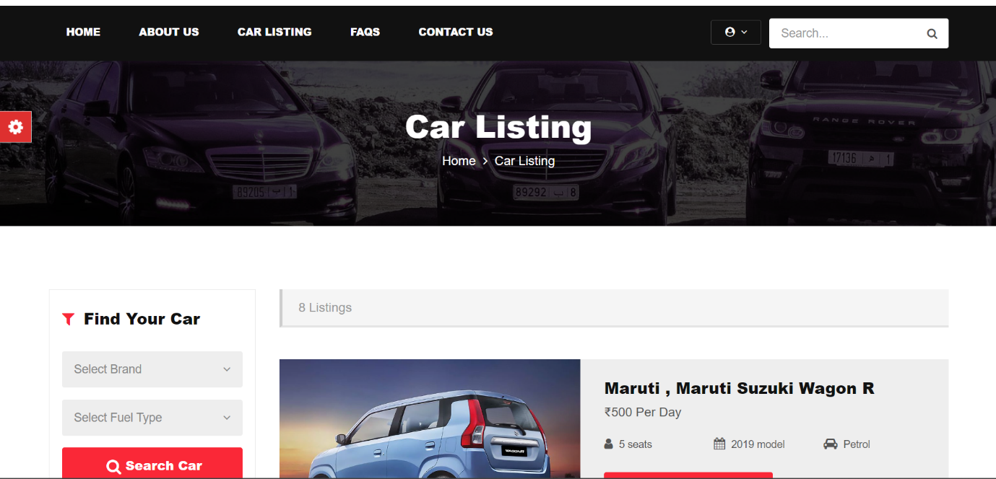

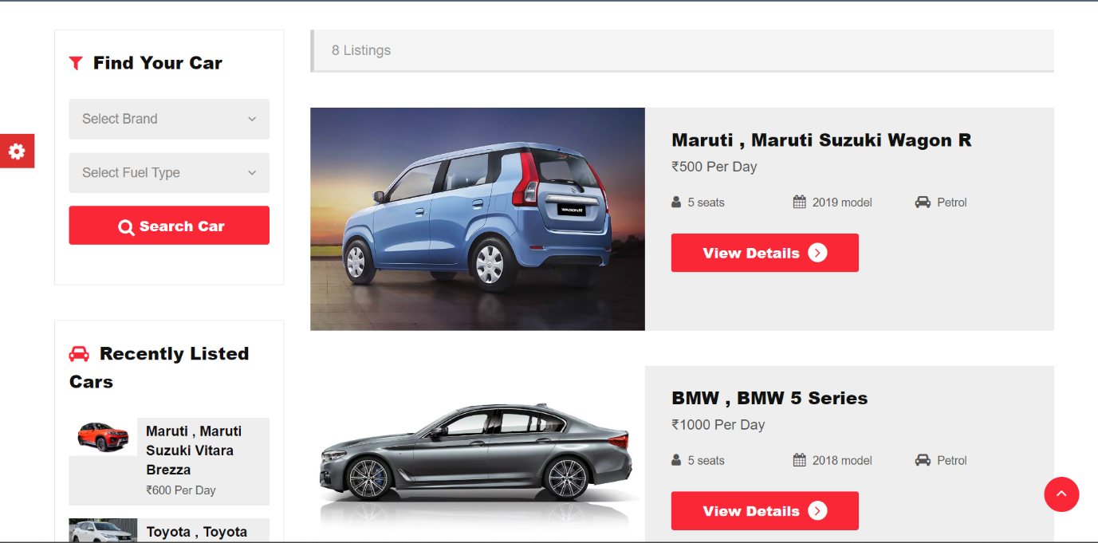

* **Contact Us Page:-**

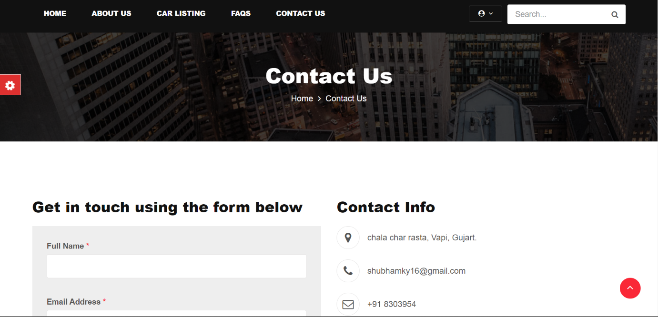

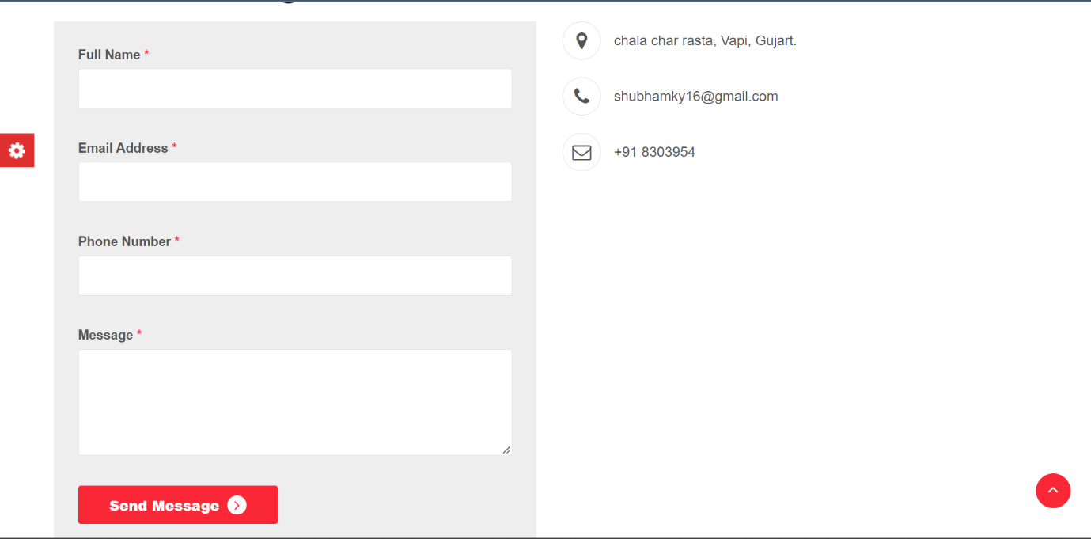

* **Sgin Up and Login Page:-**

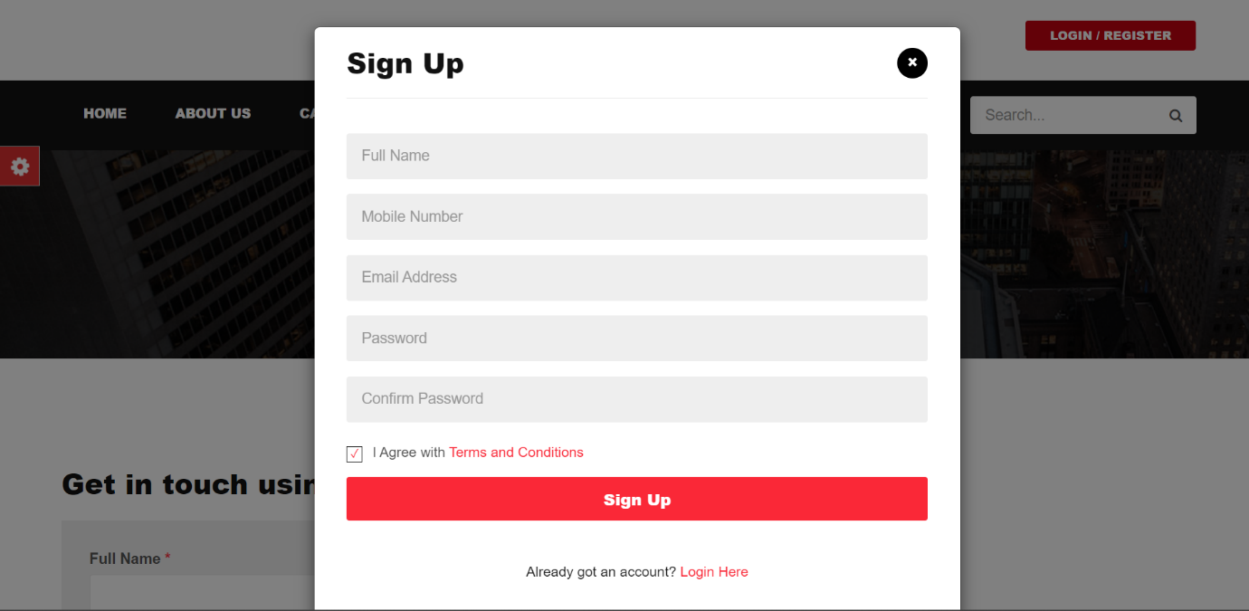

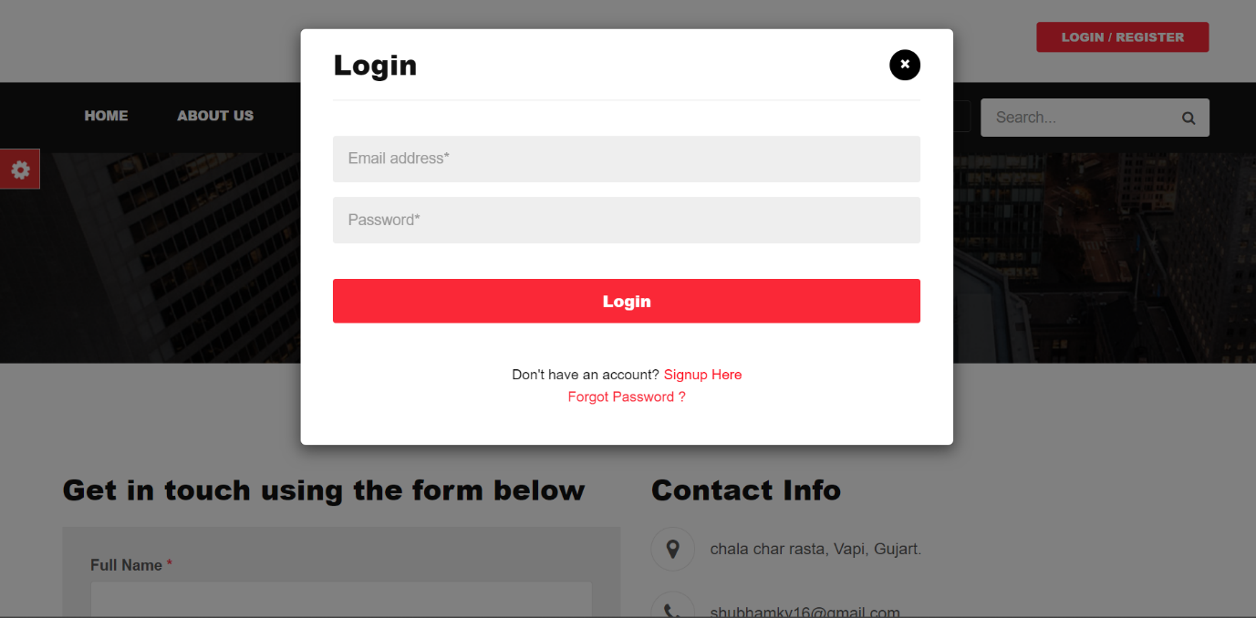

* **Admin Login Page:-**

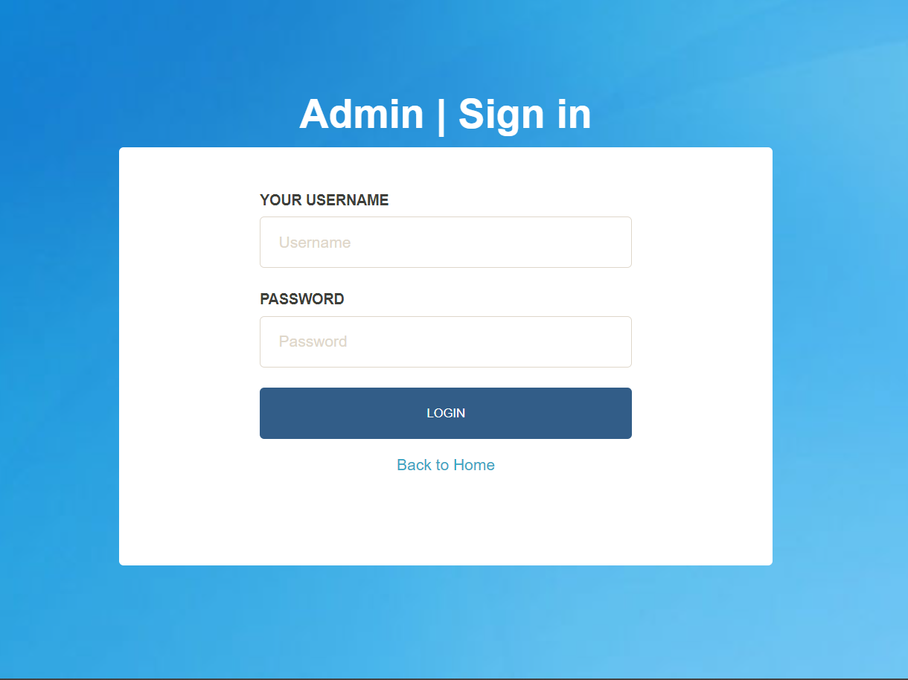

* **Admin Panel Pages:-**

